**1. The player1(master branch) modified the code, and pushed it. But pushing failed, because adversaries modified the code and pushed it earlier.**

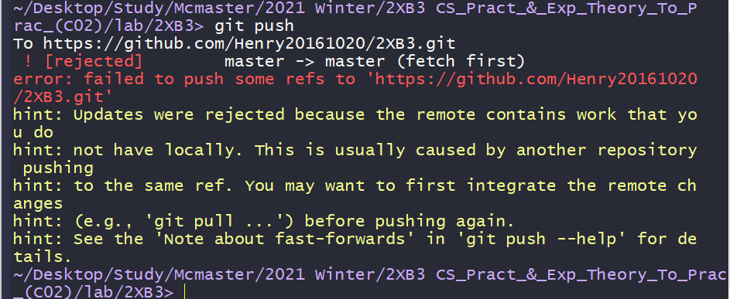

**2. The player1(master branch) pulled again, and modified the code.**

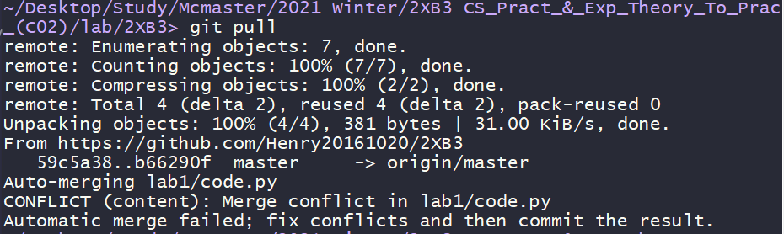

Before modify

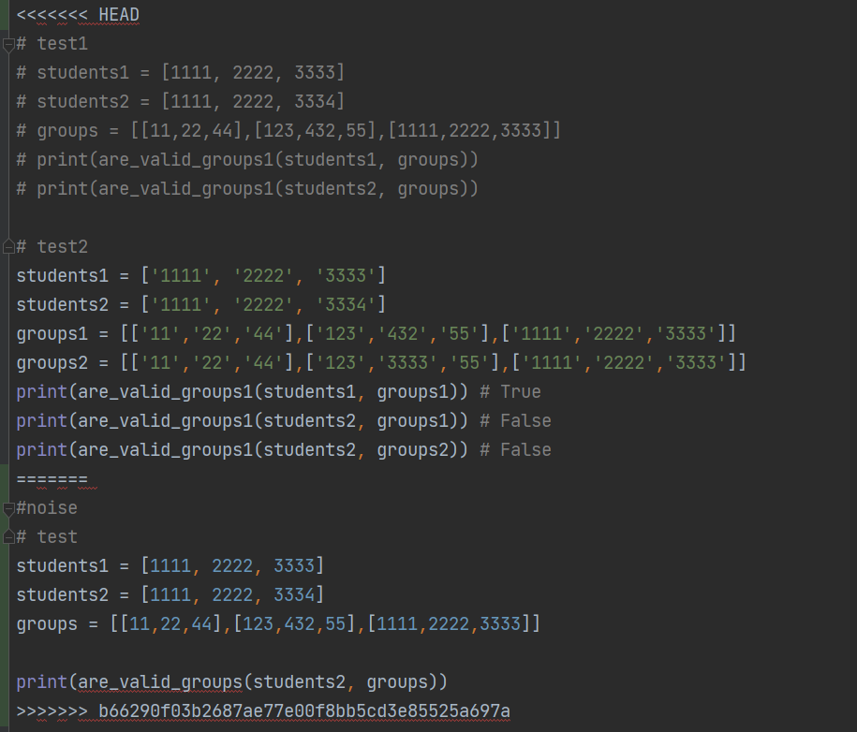

After modify

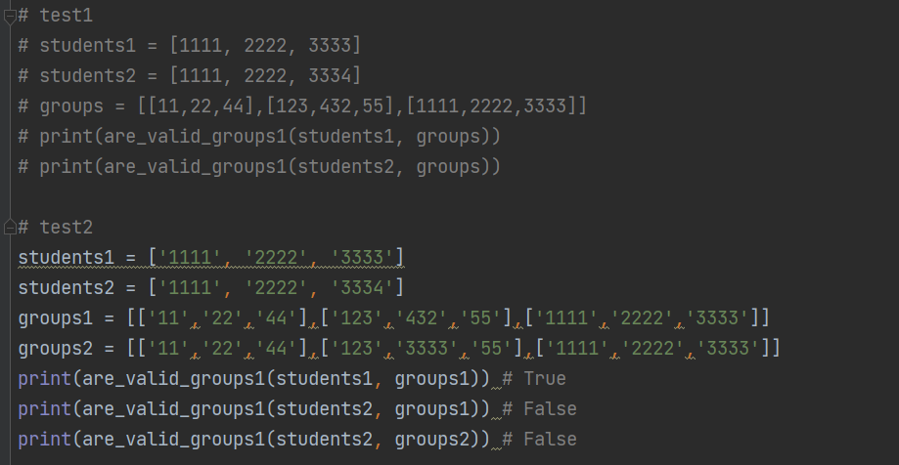

**3. The player1(master branch) added, committed, and pushed again, but it also failed. > Maybe one of the adversaries was also on the master branch, so the player one failed to push the file.**

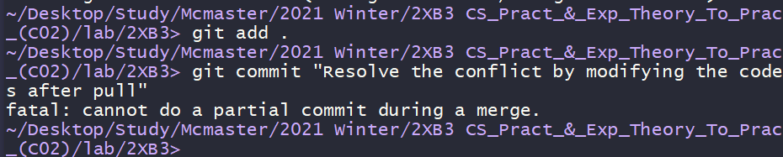

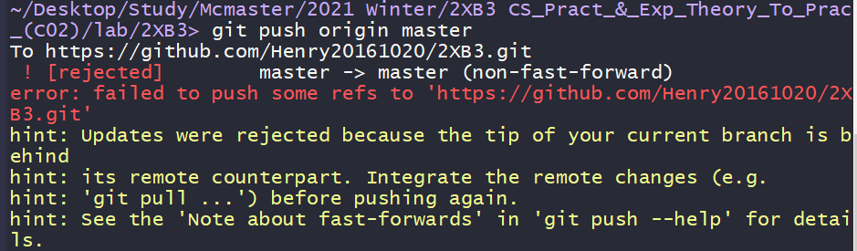

**4. The player1 changed the branch from master to branch1, repeated the process, and it succeeded.**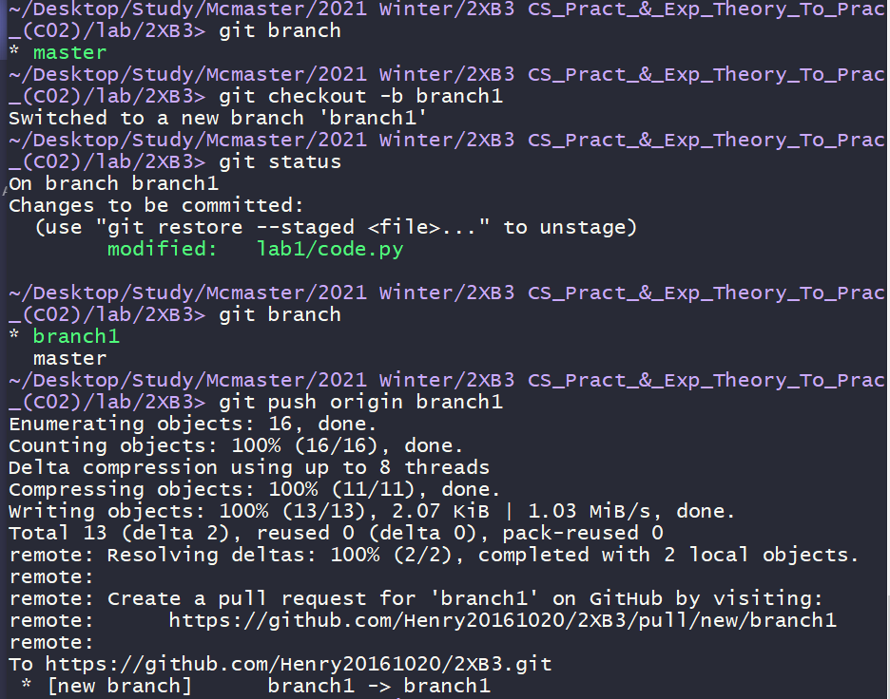

**5. When the player1(branch1) checked ‘git status’ it was on stage, so he pushed it again with commit ‘Upload 2’.**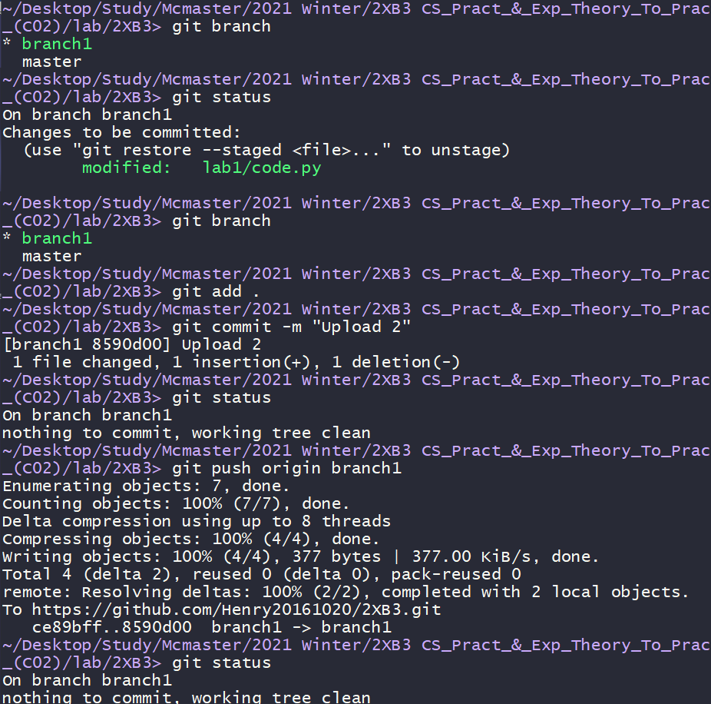

One of the adversaries’ branch(master).

‘code.py’ was not updated.

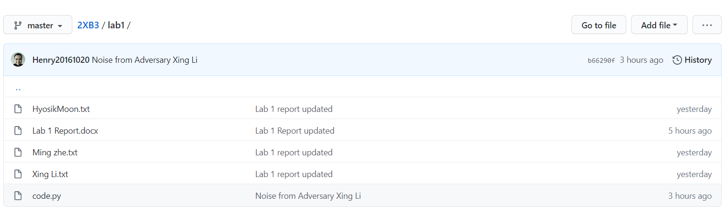

But the player1(branch1)’s file was uploaded.

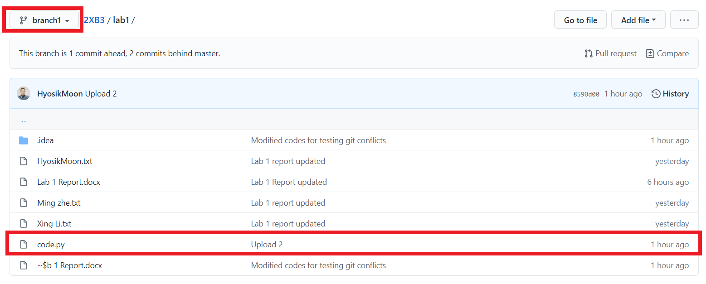

**6. The player1(branch1 -> master) changed the branch from branch1 to master. When he pulled, CONFLICT appeared.**

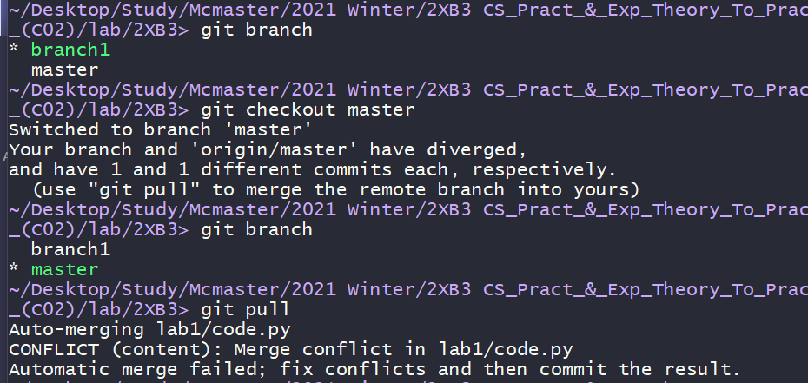

**7. When the player1(master) changed the branch, error appeared. It seemed that because he pulled from the master branch, the python file changed. So he modified the file again.**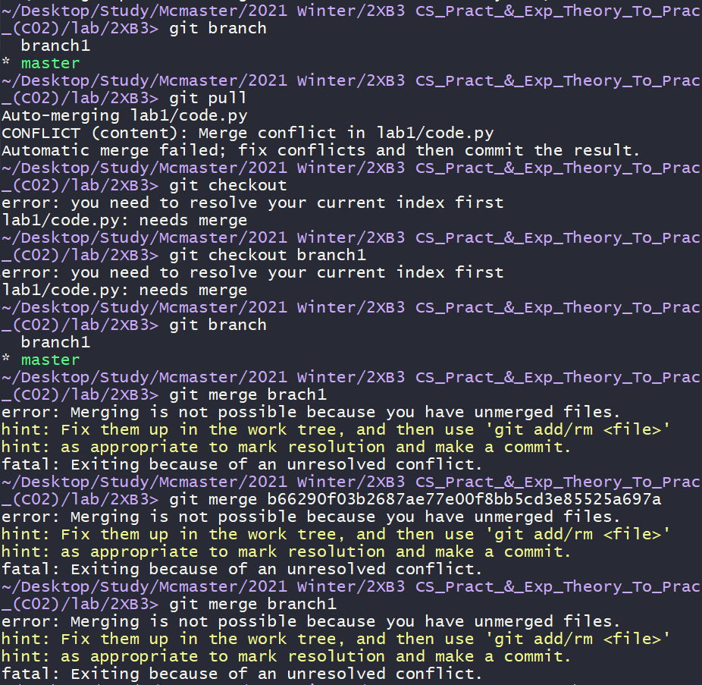

Before modify

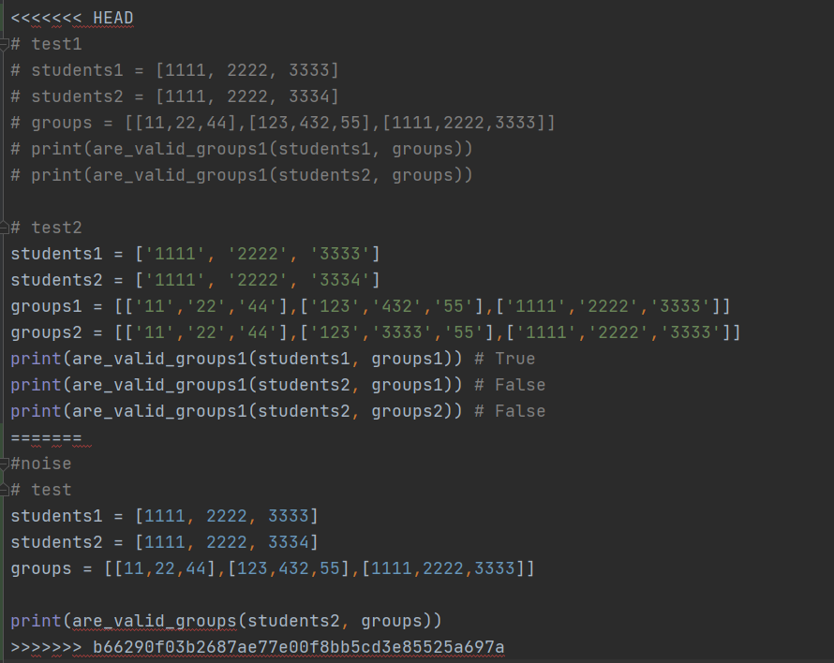

After modify

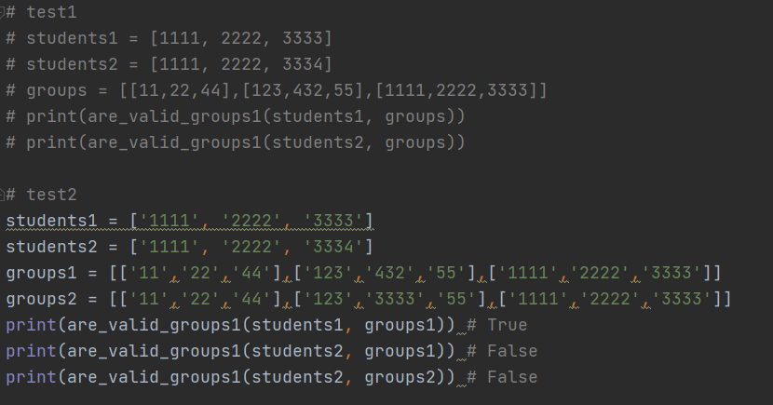

**8. After changing the code again, the player1 added, committed, and pushed the file again. And It worked.**

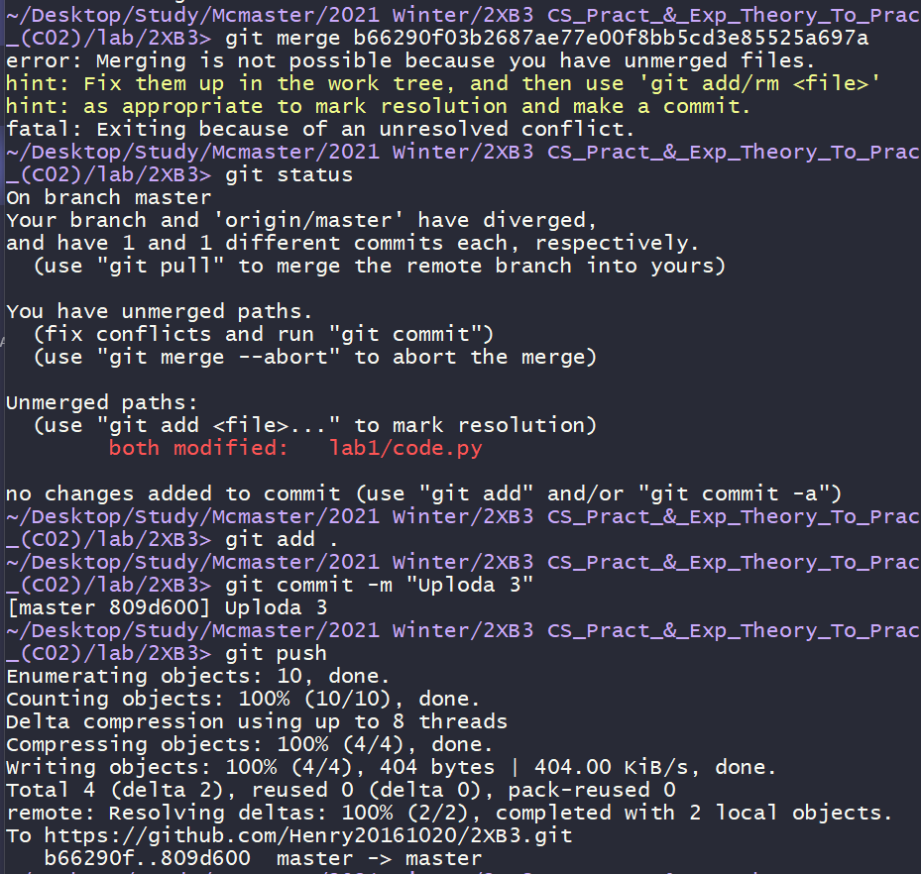

File updated(Upload3) !.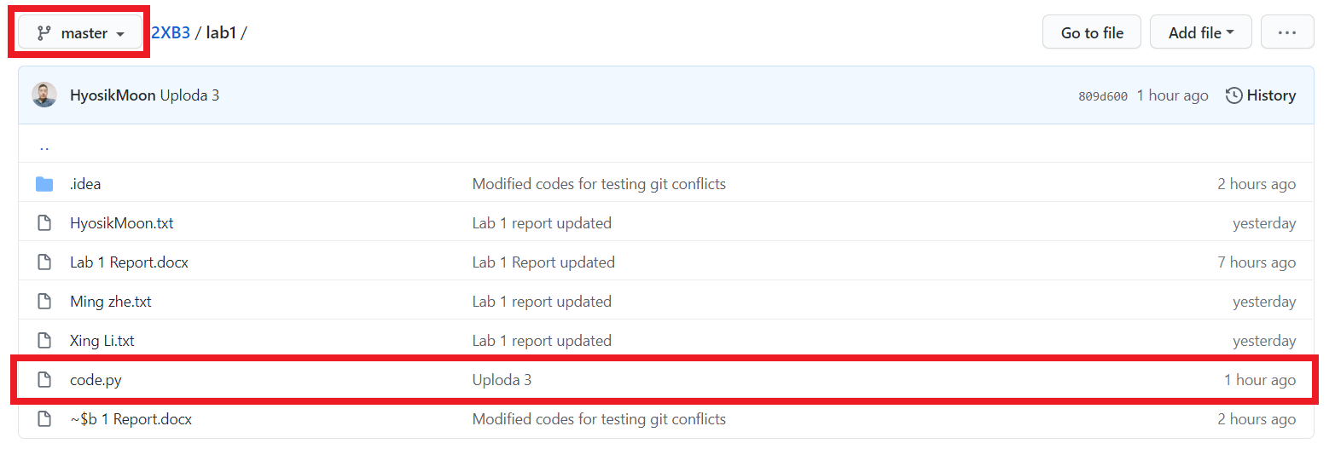

**\* Discussion**

**1. Why didn't it work when the player1(master branch) tried to push at first? Maybe one of the adversaries had been online as a master branch too. After an hour when the adversary was logged out automatically, the player1(master branch) can push the file.**

**2. In order to avoid conflicts, modify codes at a different branch. (* Don’t modify it on the master branch.)**

**3. When conflicts happen, pull the code again, modify, and push it. (* or Merge other branches when they are using different branches)**